**DATA ANALYSIS-**

1)Top Items sold every year –

* **Year 2022-**

* **Year 2023-**

* **Year 2024-**

**2)**

* **Comparison between forecasted values and actual values -**

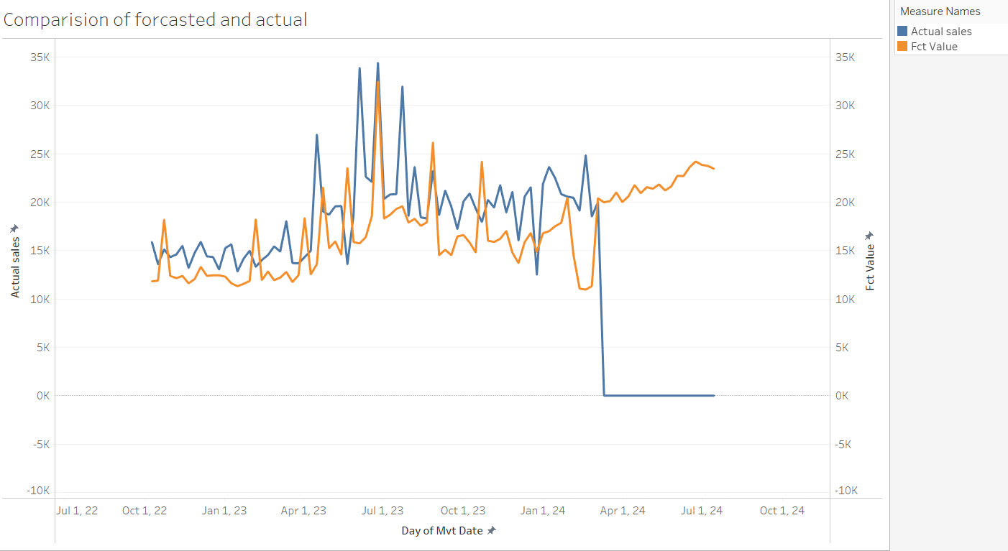

3)

* Number of items sold in holidays.

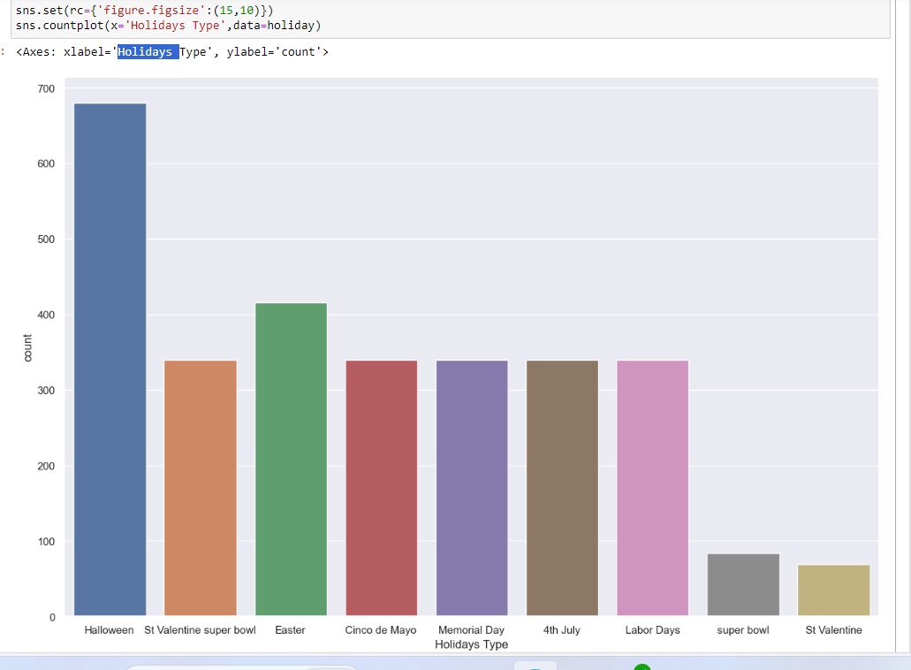

* Total sales in holidays.

Conclusion –

**The number of items sold on Halloween are more, but the total number of sales are more on 4th July compared to Halloween.**

**Accuracy**

1. **Accuracy using WMAPE-**

**Formula-**

WMAPE= SUM( ABS( [Fct Value] - [Actual sales] )) / SUM([Actual sales])

Accuracy= 1-[WMAPE]

* **Accuracy at item level**

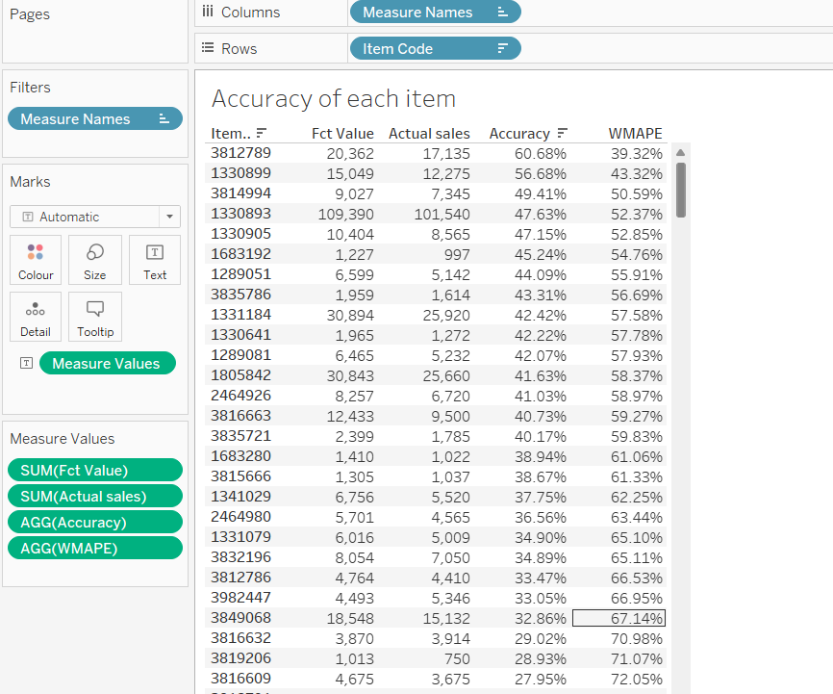

* **Accuracy of each week in 2022-**

* **Accuracy of each week in 2023-**

* **Accuracy of each week in 2024**

* **Accuracy of each month in 2022-**

* **Accuracy of each month in 2023-**

* **Accuracy of each month in 2024-**

* **Accuracy of each item in each week of 2022**

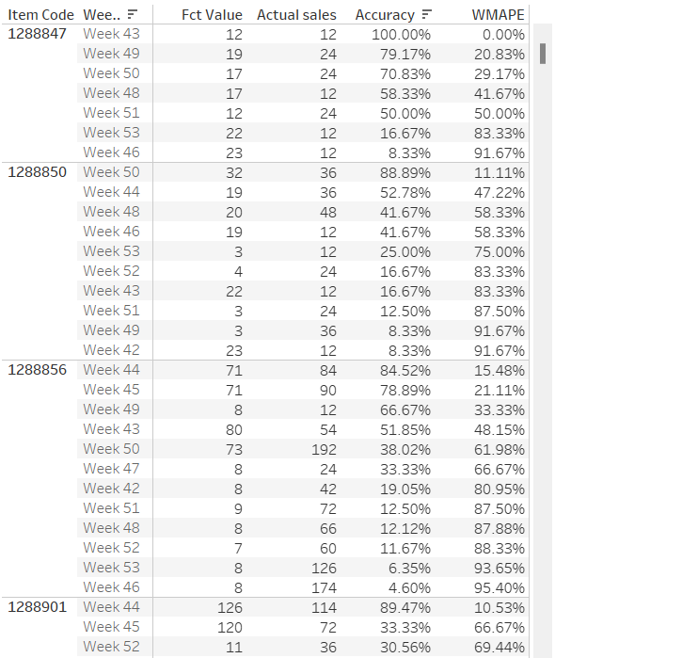

* **Accuracy of each item in each week of 2023**

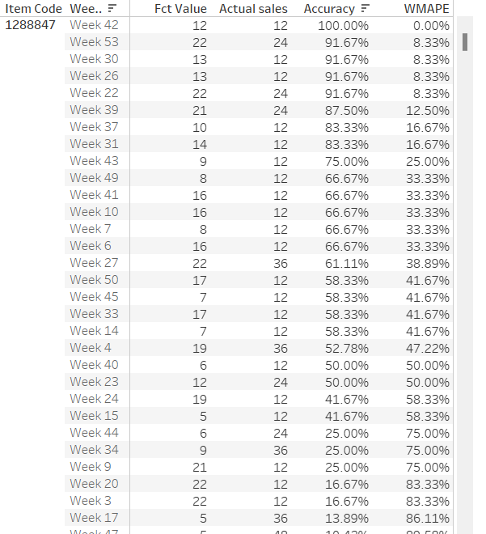

* **Accuracy of each item in each week of 2024-**

1. **Accuracy using SMAPE-**

**Formula-**

SMAPE **-** AVG(ABS([Actual sales] - [Fct Value]) / ((ABS([Actual sales]) + ABS([Fct Value])) / 2))

Accuracy = 1-[SMAPE]

* **Accuracy of each item at week level**

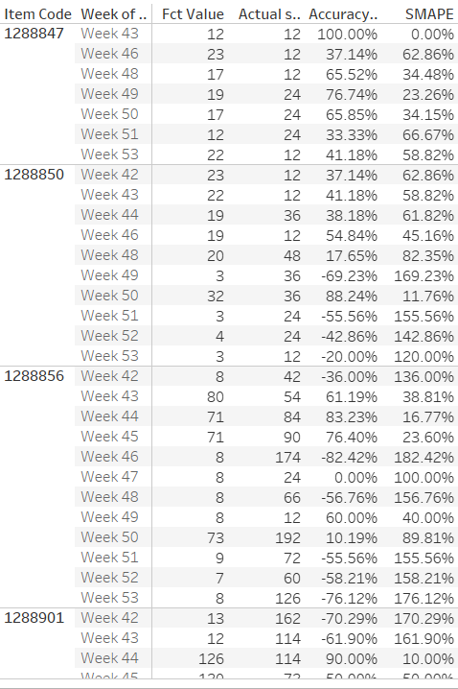

**Conclusion –**

**1)WMAPE**

Fval=5

Aval=10

**(Forecasted is less than actual)**

WMAPE= abs(Fval-Aval) / (Aval)

= (5-10)/10

= 5/10

=50% error

=50% accuracy

Fval=10

Aval=5

**(Forecasted is more than actual)**

WMAPE= abs(Fval-Aval) / (Aval)

= (10-5)/5

= (5/5)

= 100% error

= 0% accuracy

**Top 10 items sold –**

**Top 5 items sold-**

